ANSWER KEY

Study Questions for Week 19 Reading

1 Chronicles 18 – 2 Chronicles 12
“Have You Read It?” Bible Reading Campaign
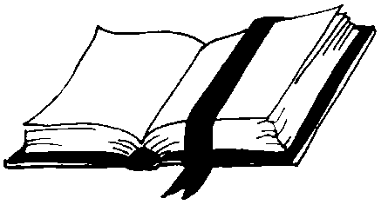
Multiple Choice Scripture References

1. Where did Solomon build the temple?
(a) Hebron (b) Gibeon (c) Moriah (d) Sinai 2 Chron. 3:1
2. Who gave Solomon an abundance of spices?
(a) Huram (b) the queen of Sheba (c) Shishak (d) Asaph 2 Chron. 9:1-9

True / False

3. Aaron’s rod was in the ark in Solomon’s time. F 2 Chron. 5:10
4. The Spirit delivered the pattern for the temple. T 1 Chron. 28:11-19

Fill in the Blank

5. “…know the God of your father, and serve him with a whole
heart and a willing mind …” (NAS) 1 Chron. 28:9
6. “…heaven and the heaven of heavens cannot contain You.
How much less this temple (house) which I have built!” (NKJ) 2 Chron. 6:18

Listing

7. List the names of the two pillars Solomon placed before the temple:
Jachin (Jakin) , Boaz 2 Chron. 3:17
8. List two things God gave Solomon besides wisdom and knowledge:
riches (wealth) , honor 2 Chron. 1:11-12

Matching: People & Places Matching: Numbers

Hanun Slew six-fingered giant 2 Divisions of Aaron’s sons

Rabbah Shamed David’s servants 40 Steps to Solomon’s throne

Jonathan Lumber for temple came 24 Day of month temple
from here construction began
Ahithophel City of Ammon destroyed 6 Year of Rehoboam’s reign
by David Shishak attacked Judah
Lebanon David’s counselor 5 Years Solomon reigned

Thought Question

God did not permit David to build the temple, yet David made preparations for his son Solomon to build it (1 Chron. 22:5). What lesson may we learn from David’s good example?

We may be limited in what we can do for God, but we should do what we can (cf. Mk. 14:8). Also, we may be able to pave the way for a great work in the next generation.

